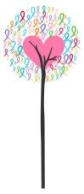

SARATOGA SPRINGS, NY
Pink Bows on Broadway ~ October 2019
SPONSORSHIP FORM
Yes! I would like to be the Main Event Sponsor ($1,500) ____
Yes! I would like to sponsor a Hero’s Pink Bow as an individual ($50) ____
Yes! I would like to sponsor a Hero’s Pink Bow as a business ($250) _____

NAME: ____________________________________________
BUSINESS NAME (if applicable): ________________________________________________
ADDRESS / E-MAIL: ____________________________________________________
CELL PHONE NUMBER/ HOME NUMBER _______________________________________
I would like my sponsorship to acknowledge
Name:

How would you like the card to read? Ideas include: Celebrating Brave Warrior (name), Honoring (name), in Memory of (name), or if you have a sentence or two of your own we will customize! We will state the Bow of Support is from ‘Your Name’ indicated above.
________________________________________________________________________________________________________________________________________________________________________________________________________________________________________________________________________________________________________________________
*Receipt of this form grants permission to display the above name for this fundraising campaign. If you would like to include a small picture and bio- send to info@floydwarriors.com. If you do not specify a Hero, your sponsorship will be made to honor floydwarriors.com.

floydwarriors.com, Inc. is a 501-c3 Not for Profit Organization 45-4185253

SAMPLE

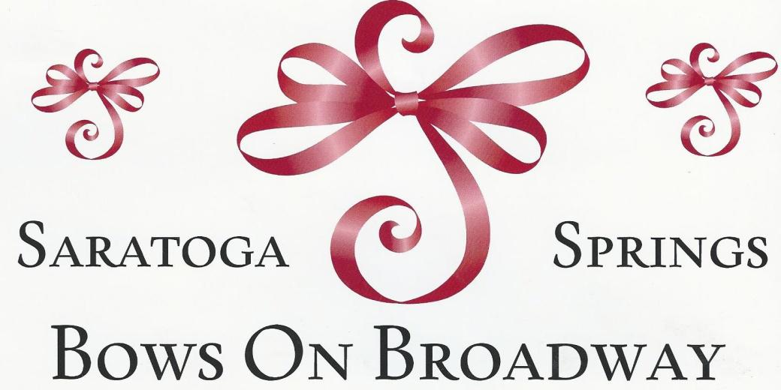

In Celebration of
Brave Warrior, Mary Smith
We Love You!
The Sisters

Floydwarrios.com Thanks You for this
‘Bow of Support!’

